# CS 255 System Design Document Template

## UML Diagrams

### UML Use Case Diagram

### UML Activity Diagrams

|  |  |
| --- | --- |
|  |  |

### UML Sequence Diagram

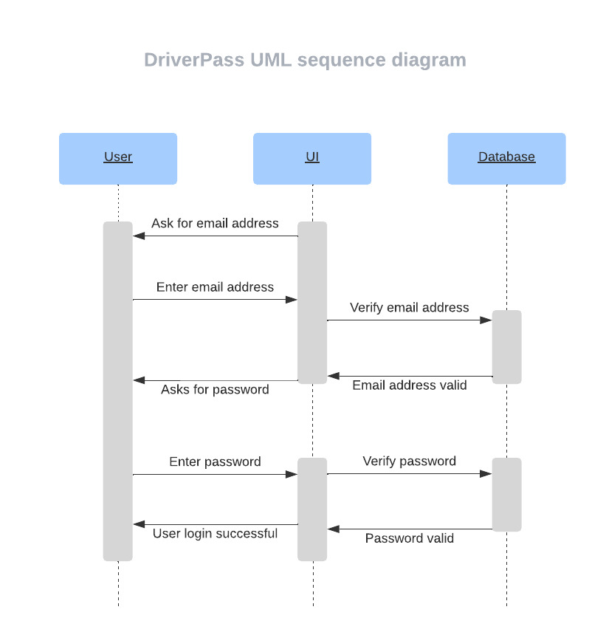

### UML Class Diagram

## Technical Requirements

The environment for the DriverPass system will be web-based, so that it can be accessed by customers online. The system back end will require an online database to store user credentials and transactional data so that it can be accessed from anywhere. Encryption will be used to secure the connections or the data exchange between the client and the server. Encryption is part of common protocols to communicate securely with the website. Students will be able to login to their accounts and customize their program by modifying their packages by adding lessons, removing lessons based on their training needs. Employees of DriverPass will be able to view student progress reports and make appointments for students to take driving lessons. Instructors and other administrative staff of DriverPass will be able to grade student tests and provide notes, advice and guidance that the students can later view. Administrative and security staff of DriverPass should have the ability to add and remove student access to the student’s DriverPass learning accounts.